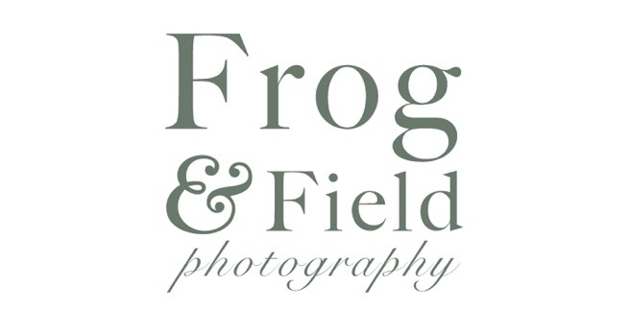

Booking Form: Abi Martin

Proposed Session Date: 12th May 2018

Equine 1 Hour Portrait Session: PRIZE
Travel: NONE

To include 5 Watermarked Images for use on Social Media

Further images are available post shoot

Date is not guaranteed until Session Fee has been paid

Many thanks for your time and I look forward to working with you

Sam

Contact Details: 07736736341 or Samantha@frogandfield.co.uk

Please allow 2 hours for your shoot. Outfit changes are encouraged and ridden images are also welcome. If doing ridden images, please ensure your horse’s tack is clean with a suitable saddle cloth etc. Depending on the horse’s temperament we may do ridden first.

For more information and commonly asked questions please visit our Website
www.frogandfield.co.uk

Please note Frog and Field do not take responsibility for horse or rider during a shoot and participating parties should act appropriately and within their own limits.

Samantha Thompson of Frog and Field Photography
20 Lakeside, Kent, ME6 5LD
Phone: 07736736341

PHOTOGRAPHIC RELEASE FORM

Client Name: Nicola Jarvis

Horse Name: Choocywoccy Do-Dah

Location of Shoot: Ashford

Date of shoot: 15th May 2018

I, the Client, grant to Samantha Thompson, the Photographer, the right to take photographs of me and my property, including, but not limited to my horse(s), in connection with the above identified subject. I authorize Samantha Thompson, it’s assigns and transferees to copyright, sell, use and publish the same in print and/or electronically.

I agree that Samantha Thompson may use photographs of me, with or without my name and for any lawful purpose, including, for example, such purposes as publicity, illustration, advertising and web content.

CLIENTS OVER 18 OR Parent or legal guardian must sign below after reading this entire document.

SIGNER STATEMENT OF AWARENESS

I, THE UNDERSIGNED, HAVE READ AND DO UNDERSTAND THE FOREGOING AGREEMENTS, WARNINGS RELEASE AND ASSUMPTION OF RISK. I FURTHER ATTEST THAT ALL FACTS RELATING THE CLIENT ARE TRUE AND ACCURATE.

Signature:

(If under 18, parents MUST sign)

Date:

Please complete the following questions and return to me to enable your shoot to run as smoothly as possible

Contact Phone number:

Name:

Email address for PayPal Invoice:

Address of yard/Location of shoot:

A brief description of how to get there:

Any special considerations, for example guard dogs or hard to find:

Horse/s Name:

Tell me a little bit about them, for example how long you have had them and what you like to do with them etc.

Would you like to be in the pictures?

